**Term 2 - 2024**

**CHEMISTRY PP3 MARKING SCHEME**

**FORM FOUR (4)**

**Time: 2½ Hours**

**Name**: …………………………………………………………. **Adm** **No**: ……………….

**School**: ……………………………………………………….. **Class**: …………………..

**Signature**: …………………………………………………….. **Date**: …………………...

**233/3**

**Marking Scheme**

**Kenya Certificate of Secondary**

(a)Write your name and index number in the spaces provided above.

(b) Sign and write the date of examination in the spaces provided above

(c) Answer **ALL** the questions in the spaces provided in the question paper

1. KNEC Mathematical tables and electronic calculators may be used for calculations
2. All working **MUST** be clearly shown where necessary
3. **This paper consists of 7 printed pages**
4. **Candidates should check the question paper to ascertain that all the pages are printed as indicated and that no questions are missing**
5. **Candidates should answer the questions in English**

**For examiners’ use only.**

**FOR EXAMINERS USE ONLY**

|  |  |  |
| --- | --- | --- |
| **Question** | **Maximum score** | **Candidate’s score** |
| 1 | 21 |  |
| 2 | 13 |  |
| 3 | 6 |  |

* + - 1. You are provided with:
* Solution **P**- acidified potassium manganate (VII)
* 0.05 M solution **Q** – oxalic acid.
* Solution **R** – 4.9 g of ammonium iron (II) sulphate - (NH4)2SO4.FeSO4.6H2O dissolved in 250 cm3 of water.

You are required to:

* Determine the reaction rate between oxalic acid and potassium manganate (VII).
* Standardize solution P.

**PROCEDURE I**

1. Using a 10 ml measuring cylinder, measure 1 cm3 of solution P and place it into a test tube on a rack. Repeat the procedure five times in separate test tubes.
2. Using a 50 ml measuring cylinder, measure 19cm3 of solution Q and place it into a boiling tube.
3. Prepare a water bath by placing about 200 cm3 of water in a 250 ml glass beaker on a tripod stand and heat it gently.
4. Place a thermometer into solution Q and place it in the water bath until it attains a temperature of 30oC.
5. Remove the boiling tube from the water bath and place it on the test tube rack. Add the first portion of solution P into the boiling tube and immediately start a stopwatch.
6. Record the time taken for solution P to be decolourised in **Table 1**.
7. Repeat the procedure (ii) to (vi) at temperatures 40oC, 45oC, 50oC and 60oC to complete **Table 1**.

**Table 1**

|  |  |  |  |  |  |
| --- | --- | --- | --- | --- | --- |
| Temperature of solution Q (oC) | 30 | 40 | 45 | 50 | 60 |
| Time taken for decolourization |  |  |  |  |  |
| Reciprocal of time (s-1) |  |  |  |  |  |

(4 marks)



(a) On the grid provided, plot a graph of the reciprocal of time (1/t) against temperature. (3 marks)

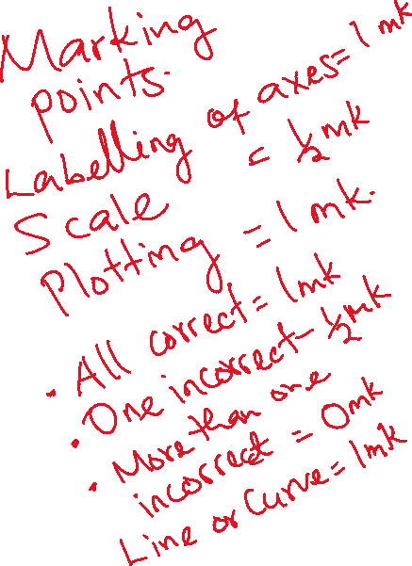

(b) From the graph, determine the time taken for the mixture to decolourise at 65oC. (1 mark)

**Read from the student’s correct graph.**

(c) How does the rate of reaction between oxalic acid and potassium manganate (VI) vary with temperature? (2 marks)

**The rate of reaction increases with an increase in temperature.**

**PROCEDURE II**

1. Fill the burette with solution P.
2. Pipette 25 cm3 of solution R into a conical flask and titrate solution P against solution R until a permanent pink colour just appears. Record the volume of solution P in **Table 2**.
3. Repeat the titration two more times and complete **Table 2**.

**Table 2.**

|  |  |  |  |
| --- | --- | --- | --- |
| **Titration** | **I** | **II** | **III** |
| Final burette reading (cm3) | **12.5** | **12.4** | **12.6** |
| Initial burette reading (cm3) | **0.0** | **0.0** | **0.0** |
| Volume of solution P (cm3) used | **12.5** | **12.4** | **12.6** |

(4 marks)

1. Determine the average volume of solution P used. (1 mark)



……………………………………………………………………………………….……………..

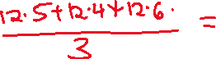

……………………………………………………………………………………….……………..

1. Calculate the concentration of solution R in moles per litre.

(Fe = 56, S = 32, O = 16, N = 16, H = 1) (3 marks)

……………………………………………………………………………………….……………..

……………………………………………………………………………………….……………..

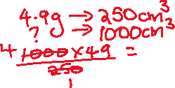

……………………………………………………………………………………….……………..

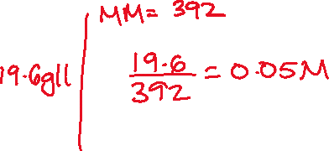

1. Given that the ionic equation for the reaction is:

5Fe2+ (aq) + MnO4- (aq) + 8H+ (aq) → 5Fe3+ (aq) + Mn2+ (aq) + 4H2O (l)

Find the number of moles of solution P used. (1 mark)



……………………………………………………………………………………….……………..



……………………………………………………………………………………….……………..



……………………………………………………………………………………….……………..

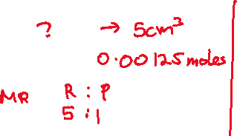

……………………………………………………………………………………….……………..

1. Determine the concentration of solution P in moles per litre. (2 marks)

……………………………………………………………………………………….……………..



……………………………………………………………………………………….……………..



……………………………………………………………………………………….……………..



……………………………………………………………………………………….……………

* + - 1. You are provided with solid B.

Carry out the tests below and write your observations and inferences in the spaces provided

1. Place about half of solid B in a clean test tube and heat it strongly.

|  |  |
| --- | --- |
| **Observations** | **Inferences** |
| **Droplets of a colourless liquid form on the cooler parts of the test tube.**  **Solid is white and the residue is also white.**  **(1 mark)** | **Hydrated salt**   1. **mark)** |

1. Place the remaining solid B in a boiling tube. Addabout 10 cm3  of distilled water and shake the boiling tube. Divide the resulting mixture into three portions.

|  |  |
| --- | --- |
| **Observations** | **Inferences** |
| **Solid dissolves to form a colourless solution.**  **(1 mark)** | **Soluble salt**  **(1 mark)** |

1. To the first portion, add sodium hydroxide dropwise until in excess.

|  |  |  |
| --- | --- | --- |
| **Observations** | | **Inferences** |
| **A white precipitate, soluble in excess NaOH.**  **(1 mark)** | **Zn2+, Al3+, Pb2+ present**   1. **mark)** | |

1. To the second portion, add aqueous ammonia dropwise until in excess.

|  |  |
| --- | --- |
| **Observations** | **Inferences** |
| **A white precipitate, insoluble in excess aqueous ammonia.**  **(1 mark)** | **Al3+, Pb2+ present**  **(1 mark)** |

1. To the third portion, add 2 drops of 2M sulphuric (VI) acid.

|  |  |
| --- | --- |
| **Observations** | **Inferences** |
| **No white precipitate**  **No effervescence**  **(1 mark)** | **Al3+ present**  **SO32-, CO32- absent**  **(2 mark)** |

1. To the fourth portion, add 2 drops of acidified barium nitrate solution.

|  |  |
| --- | --- |
| **Observations** | **Inferences** |
| **White precipitate**  **(1 mark)** | **SO32- present**  **(1 mark)** |

* + - 1. You are provided with solid L. Carry out the test below and record your observations and inferences in the spaces provided.

1. Place half of solid L in a boiling tube and add 5 cm3 of distilled water. Divide the resulting mixture into two portions.
2. To the first portion, add 3 drops of acidified potassium manganate (VII) solution and warm the mixture.

|  |  |
| --- | --- |
| **Observations** | **Inferences** |
| **Purple acidified potassium manganate (VII) decolourizes**  **(1 mark)** | **(1 mark)** |

1. To the second portion, dip a piece of litmus paper.

|  |  |
| --- | --- |
| **Observations** | **Inferences** |
| **Blue litmus paper turns red**  **(1 mark)** | **R-COOH present**   1. **mark)** |

1. Place the remaining solid L on a clean metallic spatula and ignite it in a non-luminous flame.

|  |  |
| --- | --- |
| **Observations** | **Inferences** |
| **Solid melts and burns with a yellow-sooty flame.**  **(1 mark)** |  |

**This is the last printed page**